MAG LEVEL 1 FLOOR (1)
Statics | 1. ® © Pike Close | 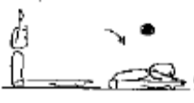
  - Sit and stretch arms sideways and overhead and place chest to knees. Hold 2 Seconds.
 | 2. ® © Dish | 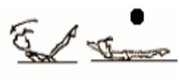
  - Roll back to dish hold with arms above head. Hold 2 seconds.
 | 3. ® © Shoulder stand to straight jump | 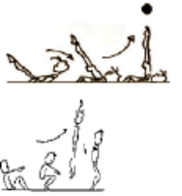
  - Place hands beside hips, roll backwards to momentary shoulder stand. Roll forward to straight jump.
Fwd Roll  (for front salto) | 1. ®© Fwd Roll to L Sit | 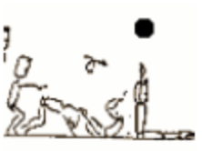
  - Forward roll to L Sit Hold 2 seconds.
Handstand (for walkover, handspring and flic flac) | 1. Angry Cat/Happy Cat position – hold 30 secs
 | 2. Angry cat on floor, turn toes under and straighten legs – keep chest in – back rounded – hold 30 secs
 | 3. Angry cat on a box – hold 30 secs
 | 4. Angry cat on a box, turn toes under and straighten legs – keep chest in – back rounded – hold 30 secs
 | 5. As above – coach lifts one leg towards handstand – as soon as good form is lost – lower and repeat
 | 6. Lying on stomach with hands against a wall – looking at hands, covering ears – chest in, bottom squeezed – hold 30 secs
 | 7. “L” Handstand |  | - Chest in and hips open  - Feet to vertical  - Legs straight
 | 8. ®© Fwd Roll Tuck handstand | 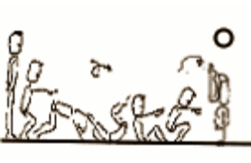
  - From stand, raise arms up sideways to vertical position. Forward roll to squat position. Place hands on floor and jump to tucked handstand position. Lower back to squat
Cartwheel / Roundoff | 1. Angry cat position – rocking from hand to hand
 | 2. F2-3.1 Side cartwheel to side handstand position, the coach checks the posture and alignment | 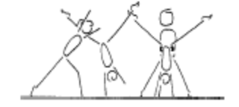 | - keep shoulders and hips square  - lunge into the side handstand  - head neutral  - maintain good body tension and alignment
 | 3. F2-3.2 Same as drill F2-3.1 – now have the gymnast rock back and forth
 | 4. F1-4.4 Cartwheel through hoops, stretch the hoops out to encourage the cartwheel to be performed in a straight line | 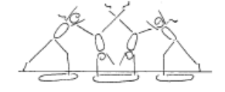 | - maintain good body tension and alignment  - pass through a plie into and out of the skill  - hands parallel, straight arms  - head neutral  - small straddle  - keep arms by ears all through the skill
 | 5. © Cartwheel from a raised surface (bench or box) to the ground (hands on the raised surface) |  | - Reach forward, straight body tilt  - Chest in, turning at last second  - Even rhythm throughout  - Open hips  - Straight direction  - Straight legs

MAG LEVEL 1 FLOOR (2)
Cartwheel / Roundoff con’t | 6. F1-4.5 Side cartwheel along a wall (can be done with back or stomach facing the wall) | 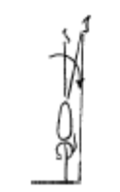 | - maintain good body tension and alignment  - pass through a plie into and out of the skill  - hands parallel, straight arms  - keep body in line bar the mat  - head neutral  - small straddle  - keep arms by ears all through the skill
 | 7. F2-3.3 Perform cartwheel between 2 supersoft mats
 | 8. ®* Cartwheel to side
 | 9. Corbettes from beat board
Backward Roll (for back salto) | 1. F2-4.1 Have the gymnast lie on their back on a supersoft mat, their head is just off the edge, the gymnast places their hands on the floor and performs a backward roll. Once this is mastered they can start from a tuck sit on the supersoft mat | 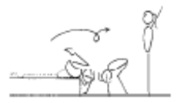 | - confidence and understanding  - legs together  - land on feet and stand  - use hands effectively
 | 2. F2-4.2 Backward roll in a channel, the gymnast performs the backward roll between 2 supersoft mats, or low shapes | 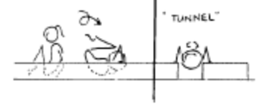 | - confidence and understanding  - legs together  - land on feet and stand  - use hands effectively
 | 2. Straight jump rebound straight jump
FWO, BWO & Tic Toc | 1. F2-5.4 Bridge with feet raised on a box
 | 2. From stand close to wall – push hips fwd and look back to touch wall behind – keep arms close to head | 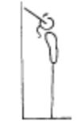 | - keep hips in line with feet  - stretch up first then open shoulders to initiate the back arch  - keep gluteal muscles tight  - maintain good body tension and alignment
Hurdle | 1. F4-2.1 Stand in dish shape leaning fwd against a wall

MAG LEVEL 1 BARS (1)
Front Support /Casts | 1. Hold front support on floor | 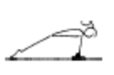 | - straight arms throughout the jump to front support  - chest rounded
 | 2. Hold front support on box
 | 3. © Jump to front support with straight arms, from feet under bar, (bar at chest height or above in starting position) | 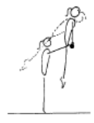 | - Arms straight throughout  - Chest in and hips open
 | 4. Shrugs | 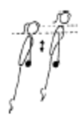 | - straight arms throughout the jump to front support  - chest rounded
 | 5. Holding ‘lean fwd’ position on the bar in front support
 | 6. B2-3.5 Support swings on parallel bars | 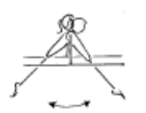 | - arms must stay straight  - head neutral  - fast backward body snap action  - dish shape at the front and back ascent peak phase
 | 7. Spotted casts | 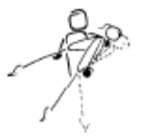 | - arms must stay straight  - head neutral  - fast backward body snap action  - dish shape at the ascent peak phase
 | 8. © 2 x Casts – hips clearly off the bar |  | - Strong pike to strong heel lift  - Straight body  - Chest in  - Hips open at top of cast
Fwd Roll Dismount | 5. ®© Fwd roll to L hang | 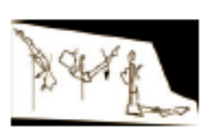
  - Roll forward to L hang (momentary)

MAG LEVEL 1 BARS (2)
Pullover | 1. B2-1.1 Tuck leg lifts on wedge x 5 | 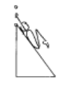 | - bring knees to chest  - maintain good body tension and alignment
 | 2. B2-1.2 Hold a bar (or rope) in hands, rotate backwards to touch feet on or near the floor | 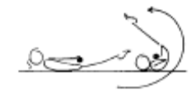 | - keep bar near hips  - legs together  - initiate rotation
3. Chin up hold

10 sec
 | 4. © B2-1.3 Perform an assisted pullover using a ‘wedge’ shape tied to the bar | 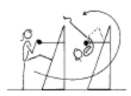 | - bring chin to the bar, simultaneously kick legs up to the vertical line and then around the bar  - join feet early  - fast rotation  - move wrists quickly  - finish in good front support
 | 5. ® © Back Hip Pullover – coach assisted | 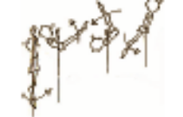
  - From hang, back hip pullover to front support with coaches’ assistance. Show position.
Back Hip circle | 1. B3-1.2 Hold a dish support and an inverted dish hang (may need coach assistance | 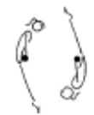 | - head neutral  - maintain good body tension and alignment
Long Swings & Long Swing Pullover | 1. B1-4.1 Perform dish and arch shape on floor | 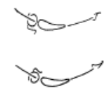 | - maintain good body tension and alignment
 | 2. B1-4 Hang in arch, dish and straight for 5 seconds each | 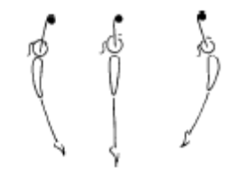 | - Hang in an arch position for 5 seconds (key position for the ‘tap’ later on)  - maintain good body tension and alignment  - maintain a rounded ‘bow’ shape  - relaxed shoulders  - open hips (feet back)  - Hang in a dish position for 5 seconds  - maintain good body tension and alignment  - maintain a rounded ‘dish’ shape  - relaxed shoulders  - Hang in a straight position for 5 seconds  - maintain good body tension and alignment  - maintain a straight shape  - hips open
 | 3. B2-4.1 Coach places one hand in front of gymnast’s feet and one hand behind gymnasts feet, from a straight hang on the bar the gymnast tries to hit both targets with feet | 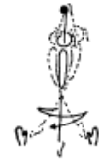 | - head neutral  - maintain good body tension and alignment  - a strong rhythm must be visible  - gymnast must feet a good rhythm
 | 4. ®© Tension swing, tension swing, tension swing to dismount | 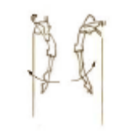  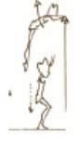
  - Press legs down to tension swing backwards and forwards. On third backward swing dismount to stand
Kips | 1. Kip drill on ladder – with straight arms (turn head to side)

MAG LEVEL 1 VAULT (1)
Bounce /Spring | 1. Ankle raises x 20 with both feet then 15 on each leg
 | 2. V1-1.1 Assisted bounces on the floor – coach holds the gymnast by the hands in front
 | 3. V1-5 Springing Circuit – variety of 8 objects | 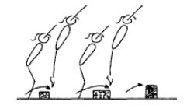 | - maintain good body tension and alignment  - continuous bouncing, no pauses or stops  - easy clearance of the objects
 | 4. V1-4 10 skips with a skipping rope
Running | 1. V2-3.1 Stand swing arms bent 90’ | 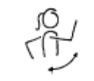 | - bent arms - arms do not drop, or straighten out  - alignment - arms do not swing across body or out to the side  - arms have 90’ bend, lift to eye level and swing back to body line
 | 2. fast run over beat board- consistent speed and stride
 | 3. V2-3.2 From stand – march lifting knees and using arms | 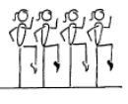 | - lift knees  - toes pointed  - arms have a 90’ bend, lift to eye level and swing back to body line
 | 4. Running drill – arm swing – using 1 knee lift while swinging both arms
 | 5. Running drill – holding foam – knees hitting foam
Hurdles | 1. Step hurdle to spring on floor – arms down when feet land
 | 2. V1-3.1 Perform hurdle from the edge of a low box – to the floor (with a fast rebound) – learning arm action
Straight Jump Vault | 1. © Short run, hurdle with arm circle, 2 feet take off, straight jump from spring board to 30cm crashmat or box | 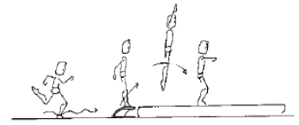 | RUN  - Tall body, slight lean forwards  - Chest in  - Quick cadence, fast reaction off floor  - Body moves forward smoothly  FIRST FLIGHT  - Hurdle is flat, not high  - Arms circle, or swing backwards then strong and fast forward & up  - Feet together fast at top of the board  REPULSION  - Arms drive through as feet impact  - At rebound feet, hips & shoulders are aligned straight  - Arms reach vertical as body leaves the board  SECOND FLIGHT  - Body stretched, hips open, arm lift  LANDING  - Chest in  - Strong landing position
 | 2. ®© 10m run, straight jump from spring board to 60cm crashmat | 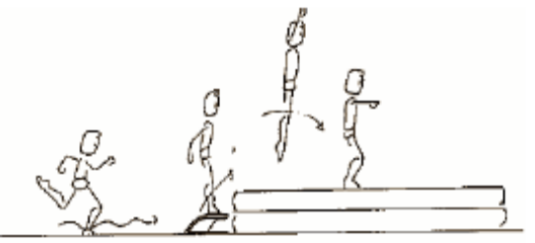
  - Run, hurdle, 2 feet take off to straight jump, arms stretched above head in flight, between horizontal and 45° on landing. (Feet hip high in jump) (Approximately 10 metres run-up)

MAG LEVEL 1 VAULT (2)
Catsprings -Handspring Vault | 1. V2-2.3 Wheelbarrow walking – hold gymnast above the knee | 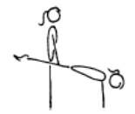 | - rounded back  - hips under & arms straight  - head neutral
 | 2. Clap push up with hands on a box
 | 3. V2-2.2 Bounce in front support on double mini | 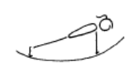 | - arms straight  - straight body  - maintain good body tension and alignment
 | 4. Straddle on 2’ box, jump off to SLP
Dive Roll / Front Salto | 1. From a run, straight jump onto 60cm mat with straight legs and chest snap
 | 2. V3-2.2 From stand dive roll up onto a supersoft mat

MAG LEVEL 1 POMMEL (1)
Front Support & Straddle Swings | ®© Front Support on Pommel Handles | 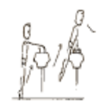
  - Place hands on handles, jump to front support (momentary)
Stride Supports & Swings | ®© Stride Support Left Leg | 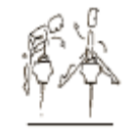
  - Tuck left leg through to stride support (momentary).
 | ®© Tuck leg back through to front support | 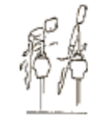
  - Tuck leg back to front support (momentary)
 | ®© Stride Support Right Leg | 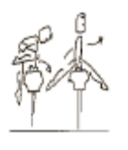
  - Tuck right leg through to stride support (momentary)
Dismount | ®© Swing Left Leg over handle to 90’ flank dismount | 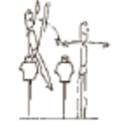
  - Swing left leg over left handle to 90º flank dismount.

MAG LEVEL 1 RINGS (1)
Hangs | ®© Tuck Hang, Momentary “L” Hold | 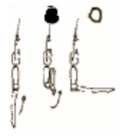
  - From hang, lift legs to tuck position (2 sec)
  - Straighten legs to momentary Lsit
Swings | ®© Basic Long Swing x 2 | 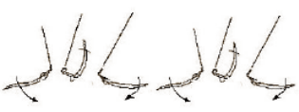
  - Long hang swing backward, swing forward. Long hang swing backward (30’ each side of vertical on all swings)
Dismounts | ®© Dismount on the back swing | 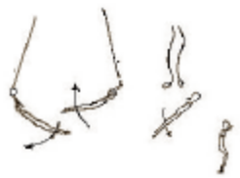
  - On the third backward swing dismount to stand

MAG LEVEL 1 P BARS (1)
Swings | ®© Jump to straight body support swing fwd & bwd | 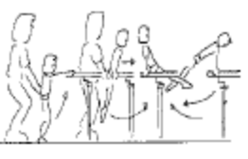
  - Place hands on ends of rail, jump coach assisted through straight body support to swing forward and backward
 | ®© Swing fwd & bwd x 2 | 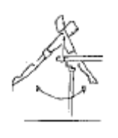
  - Swing forward and backward (45 degrees)
Dismounts | ®© Dismount releasing bar to stand | 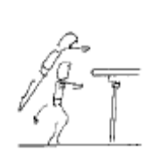
  - On the third backward swing, dismount 70 degrees (feet bar height) releasing grasp on bar.

